**Homework 11: CNN Accelerator, buffers**

**Issued:** May 23 (Tuesday), 2023 **Due:** May 29 (Monday), 2023

**What to turn in**: **Copy the text from your MODIFIED codes and paste it into a document**. If a question asks you to plot or display something to the screen, also include the plot and screen output your code generates. Submit either a *.doc or *.pdf file.

**\*\*\*\*\*\*\*\*\*\*\*\*\*\*\*\*\*\*\*\*\*\*\*\*\*\*\*\*\*\*\*\*\*\*\*\*\*\*\*\*\*\*\*\*\*\*\*\*\*\*\*\*\*\*\*\*\*\*\*\*\*\*\*\*\*\*\*\*\*\*\*\*\*\*\*\*\*\*\*\*\*\*\*\*\*\*\*\*\*\*\*\*\*\*\*\*\*\***

**Problem 1 (10p): Weight/Bias/Scale buffers**

Implement a CNN accelerator with weight, scale, and bias buffers in Verilog. Please see the description in lecture 12 for details.

What you have to do:

* 1. Reuse cnn_fsm.v.
  2. Complete the missing codes in cnn_accel.v:
* Reuse codes for setting configuration registers.
* Reuse codes to generate din, vld_i.
* Generate din, vld_i
* Add codes for weight, scale and bias buffers
  1. Do simulation with time = 400us and capture the waveform.
  2. Use check_hardware_results.m to verify the output images generated by the H/W simulation.

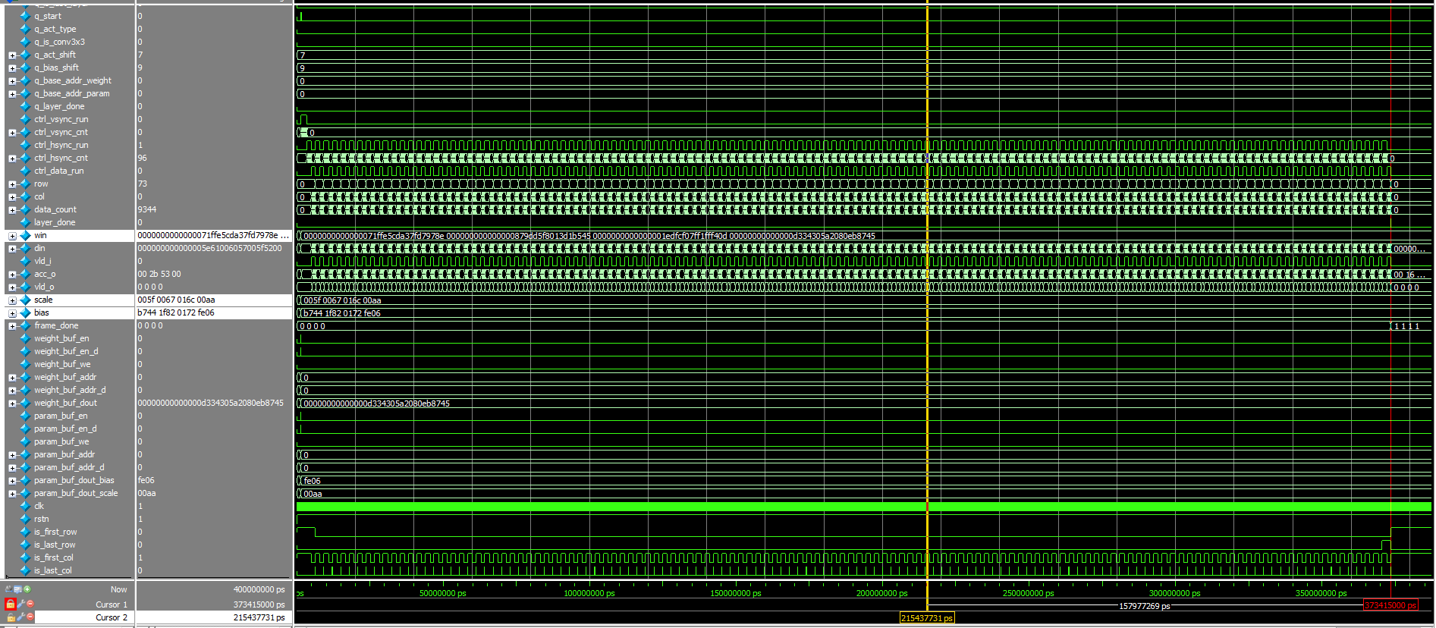

Fig. 1-1: A captured waveform of cnn_accel.

**Solution 1: Weight/Bias/Scale Buffers**

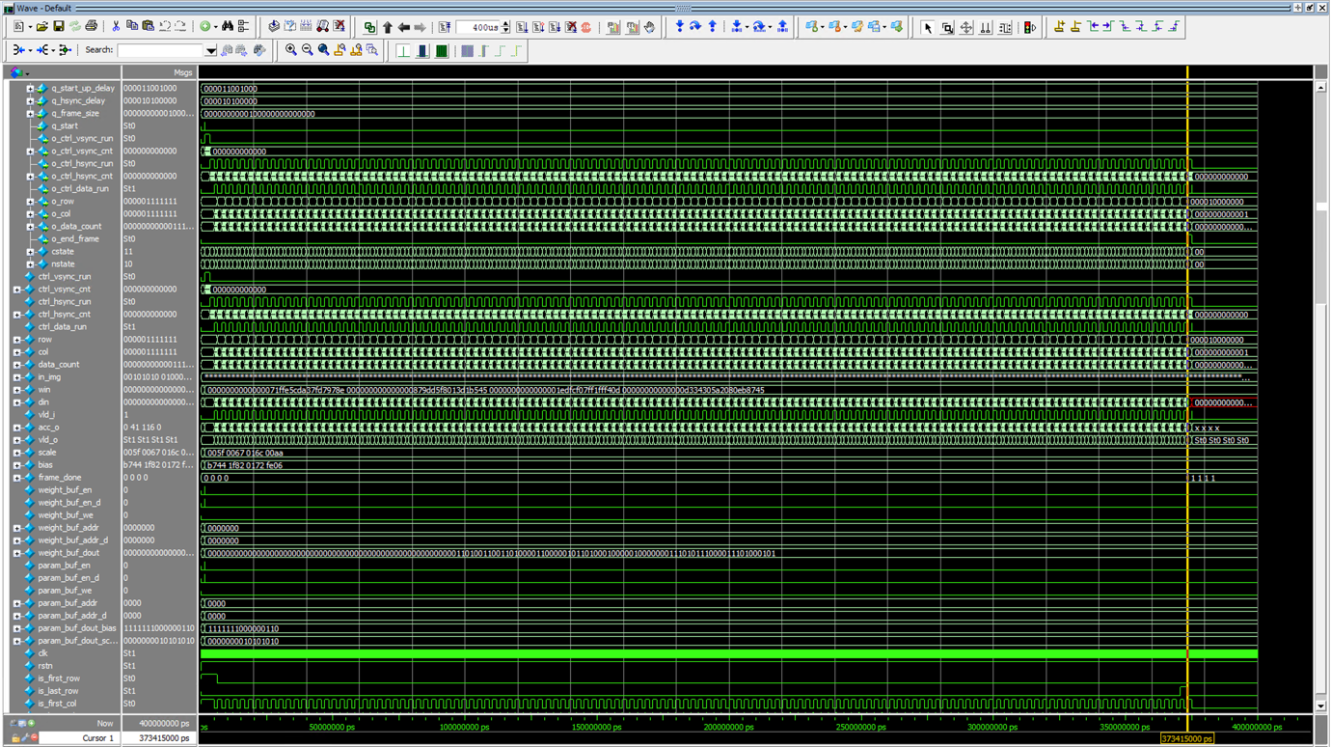

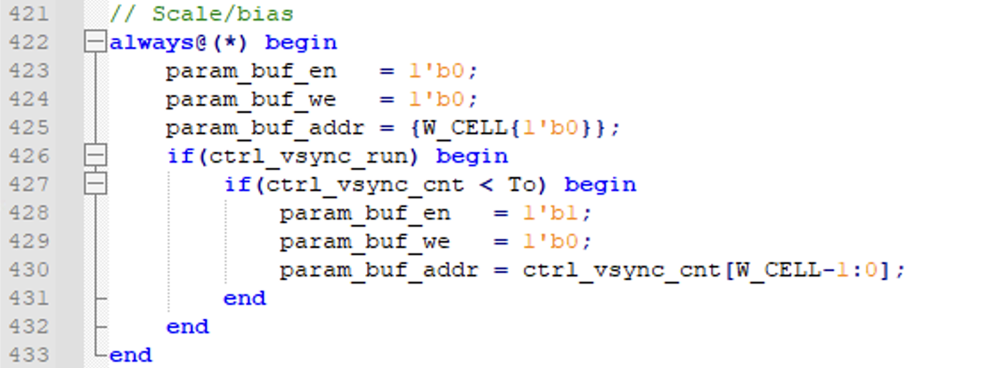

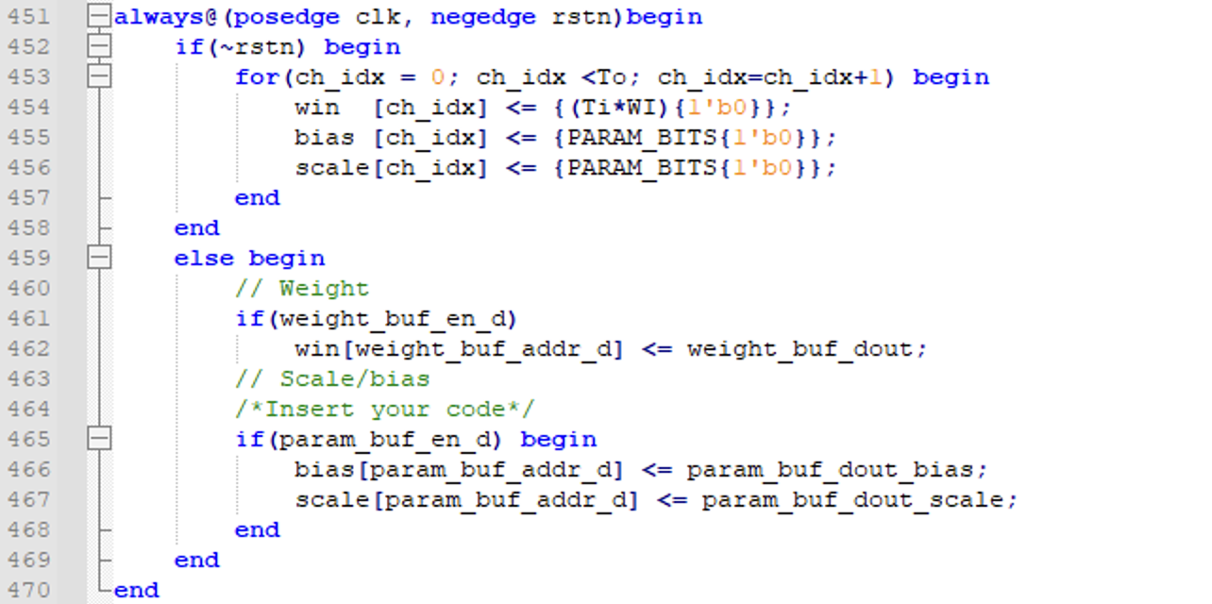

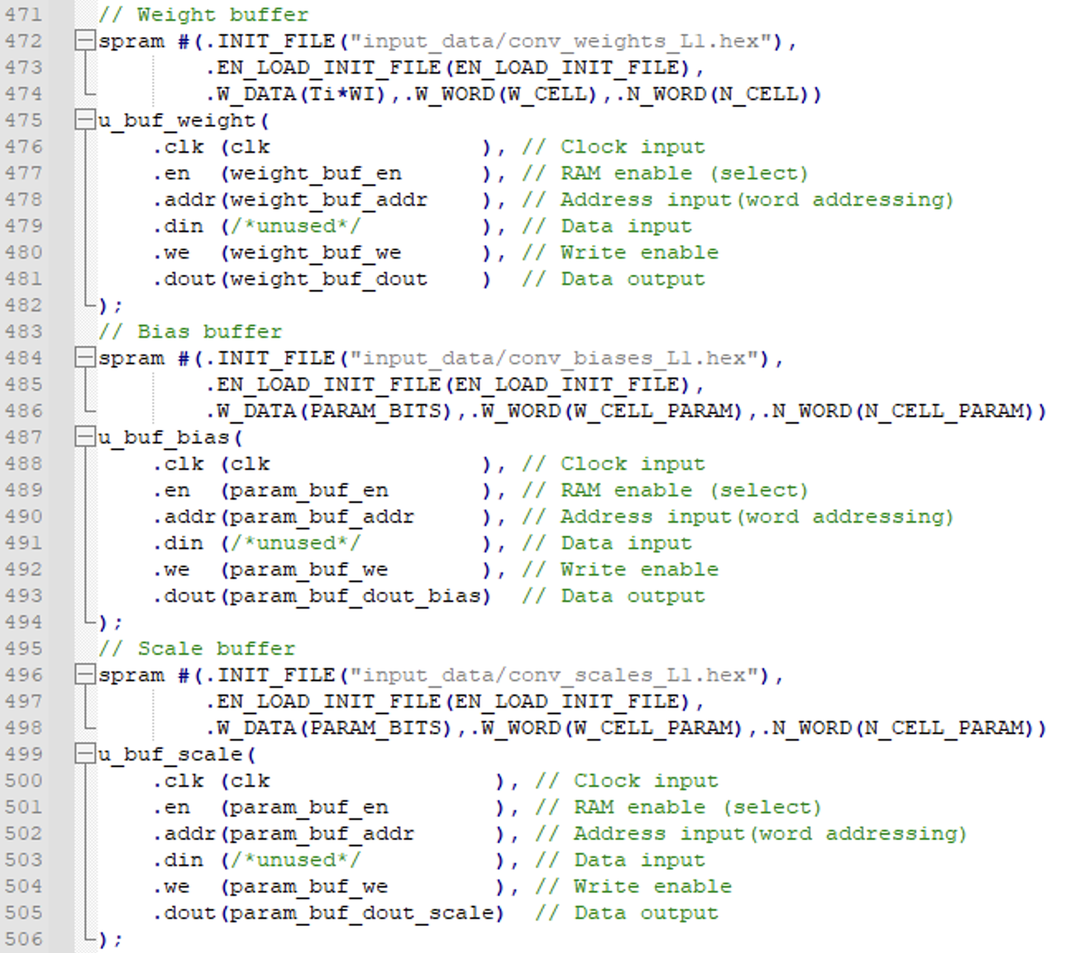

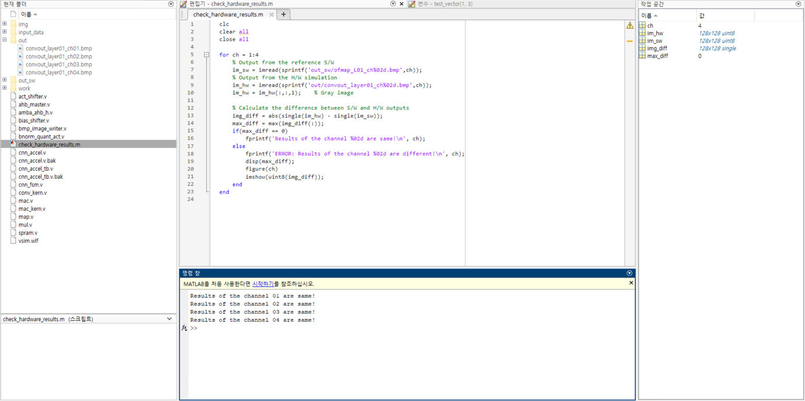

**Problem 2 (10p): Output buffers and execute three layers**

Implement a CNN accelerator in Verilog. Please see the description in lecture 12 for details.

What you have to do:

1. Reuse cnn_fsm.v.
2. Complete the missing codes in cnn_accel.v:

* Set configuration registers.
* Generate din, vld_i.
* Add codes for weight, scale, and bias buffers (Note: use parameters of all three layers.)

1. Do simulation with time = 400 us and capture the waveform.
2. Use check_hardware_results.m to verify the output images generated by the H/W simulation.

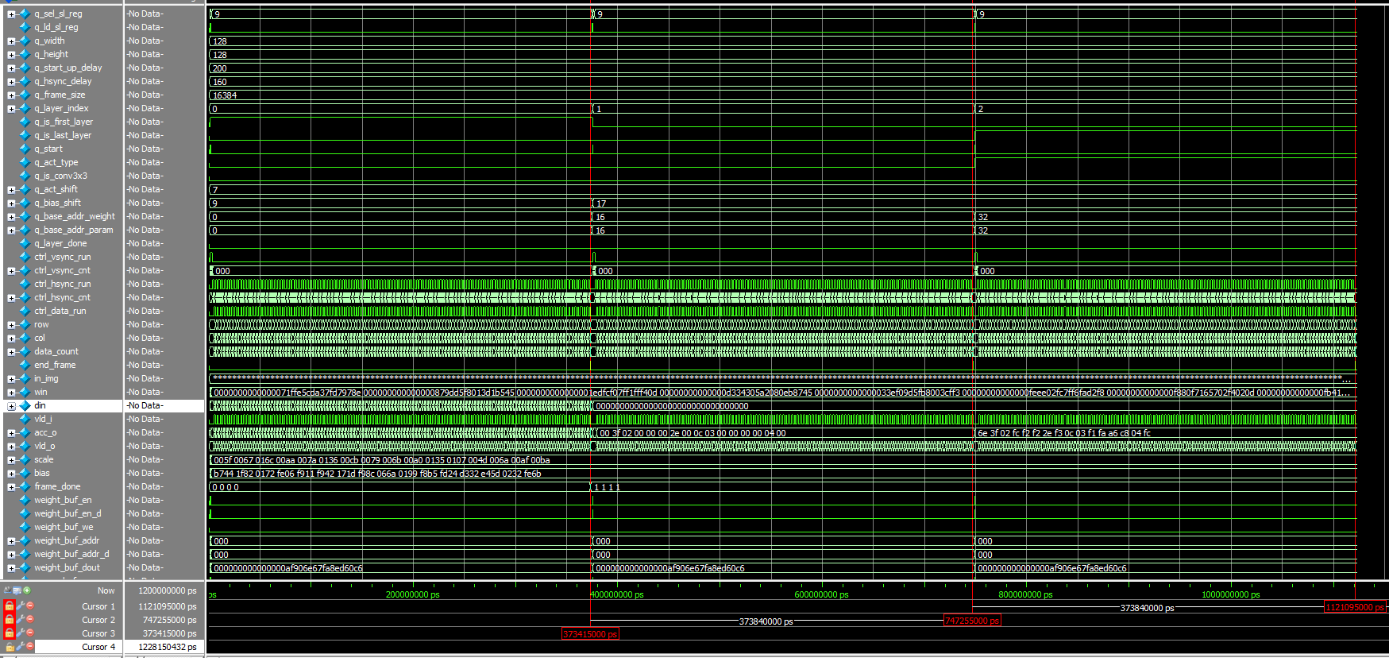

Fig. 2-1: A captured waveform of cnn_accel.v.

1. (2p) The CNN accelerator uses dual buffers to store the feature maps. Do a simulation and capture the waveform of dual buffers. Explain the motivation to use dual buffers.

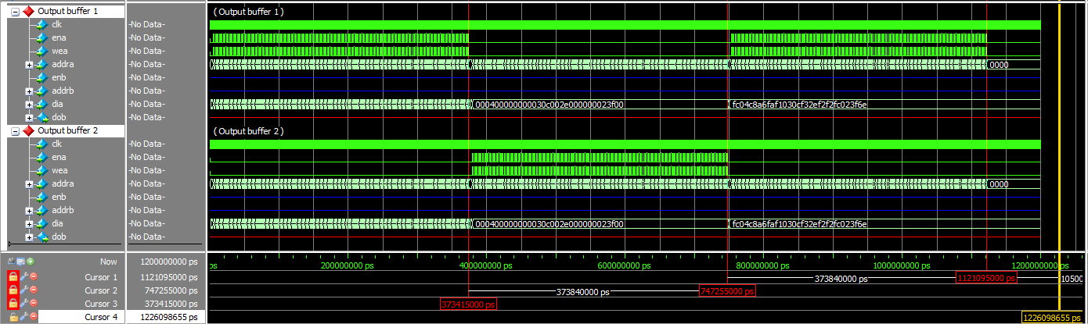

Fig. 2-2: A captured waveform of dual buffers.

**Solution 2: Output buffers and execute three layers**

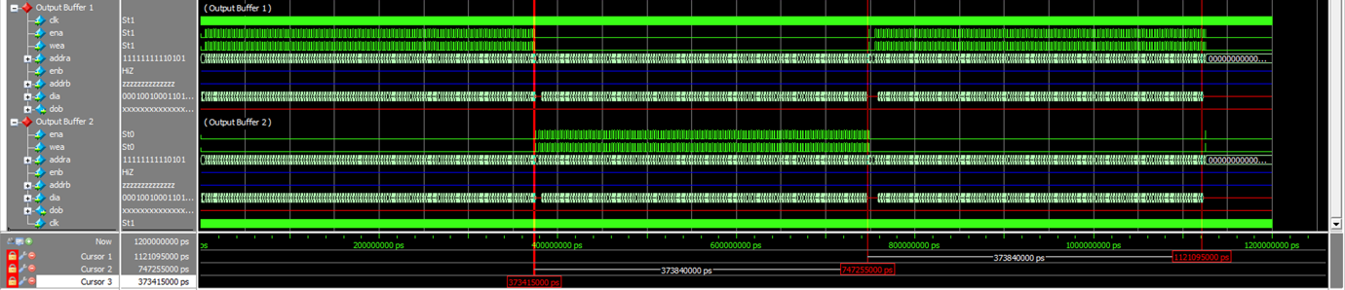

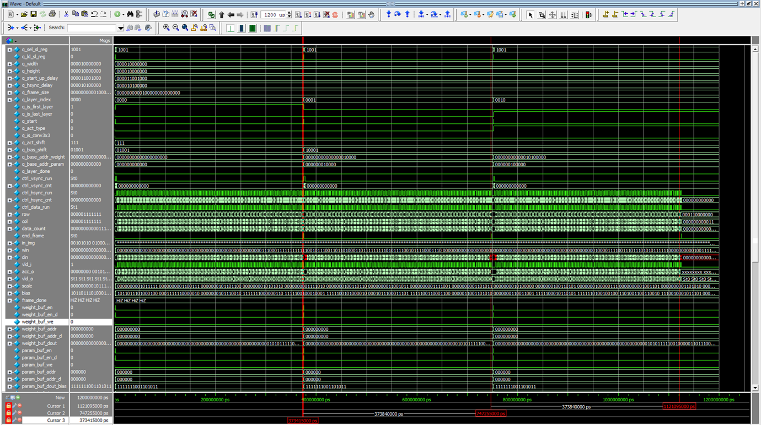

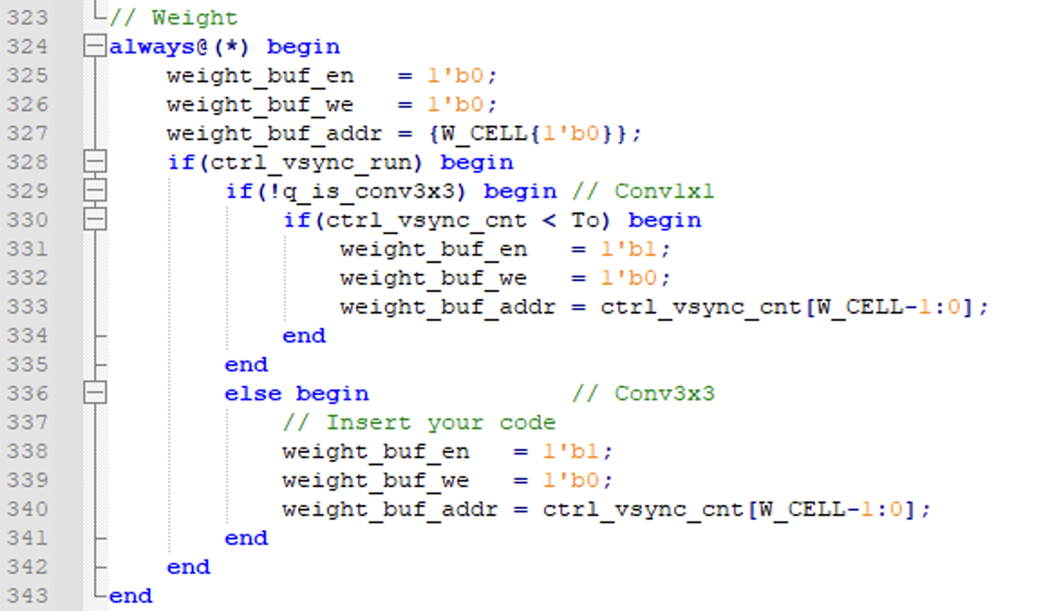

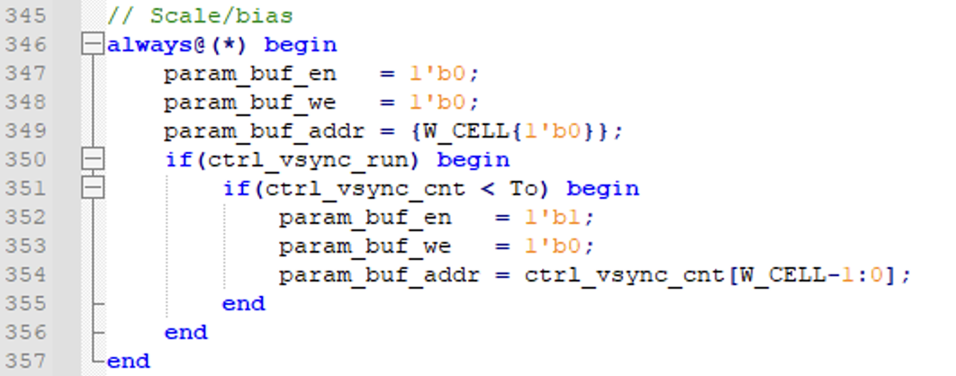

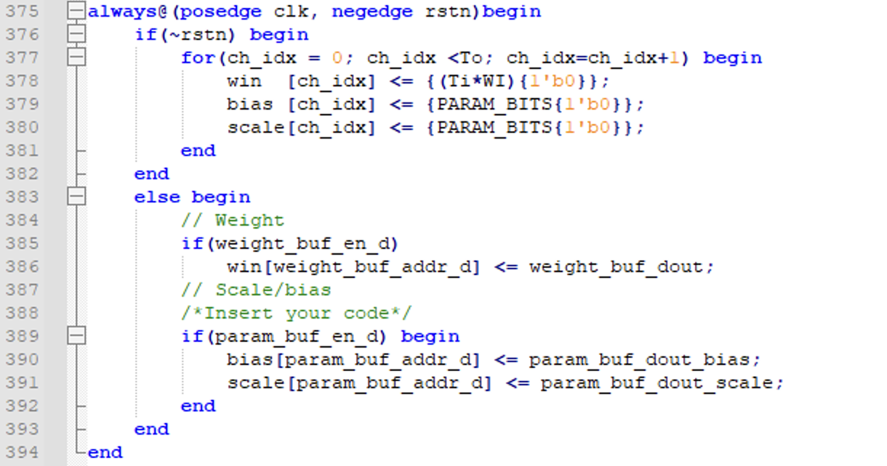

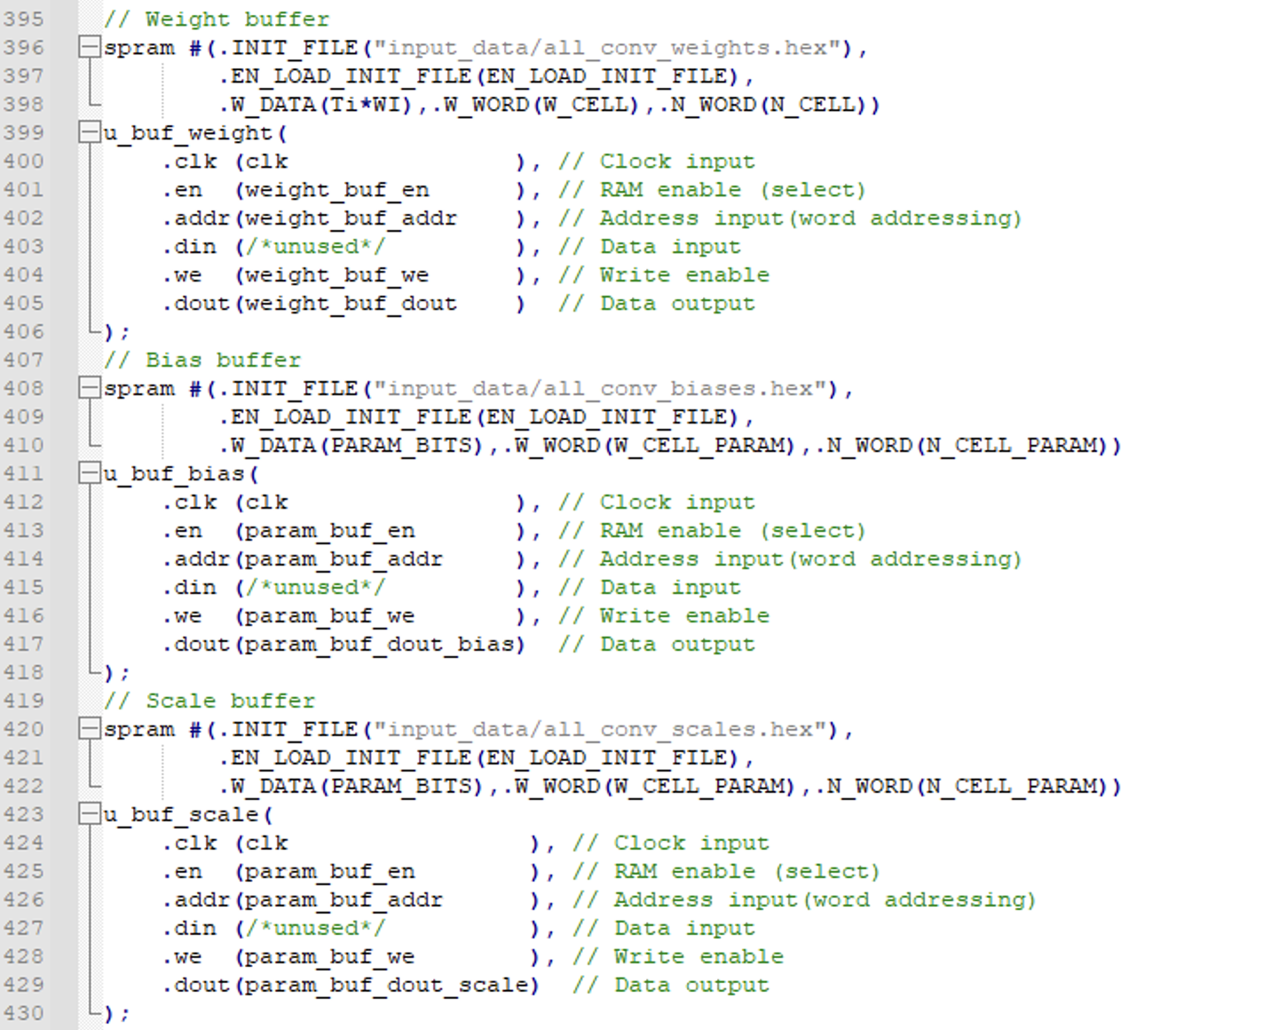

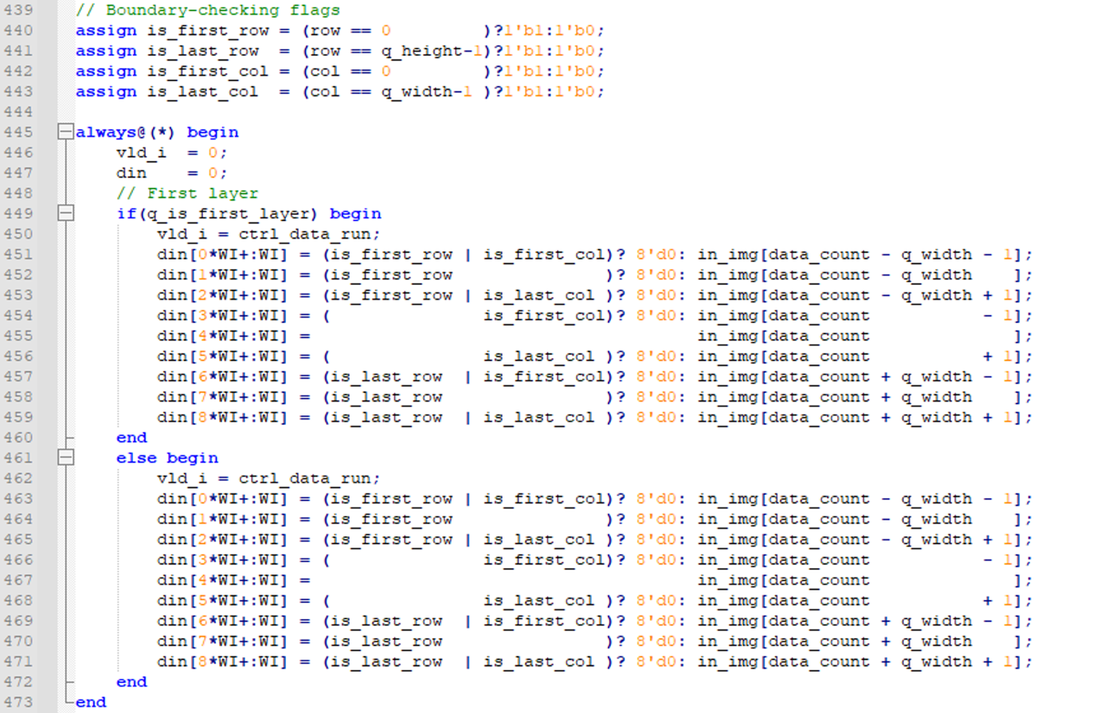

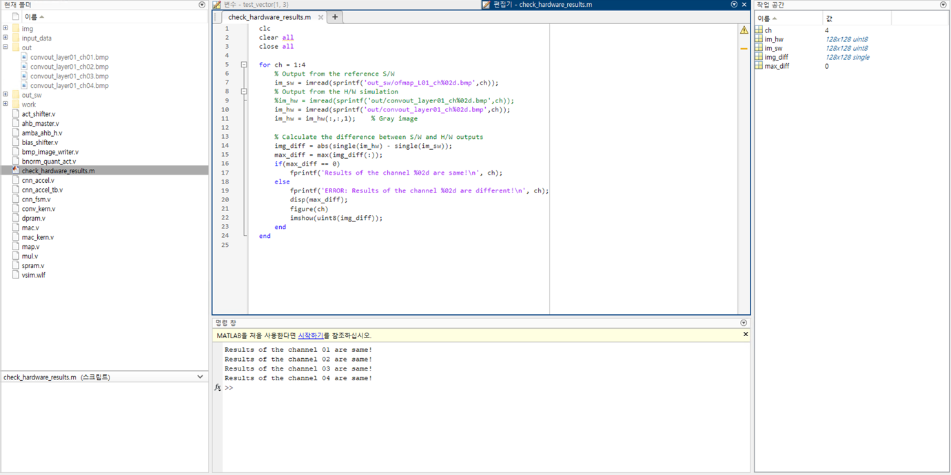

**Problem 3 (10p): Convolution 3x3**

Implement a CNN accelerator and its testbench in Verilog. Please see the description in the lecture note for details.

What you have to do:

1. Complete the missing codes in cnn_accel.v and cnn_fsm.v

* Reuse the codes in Problem 2.
* Complete the code in cnn_fsm.v to support both conv1x1 and conv3x3.

*Hint:* *conv1x1: q_is_conv3x3 == 0, conv3x3: q_is_conv3x3 == 1.*

1. Do simulation with time = 4,000 us and capture the waveform.
2. Use check_hardware_results.m to verify the output images generated by the H/W simulation.

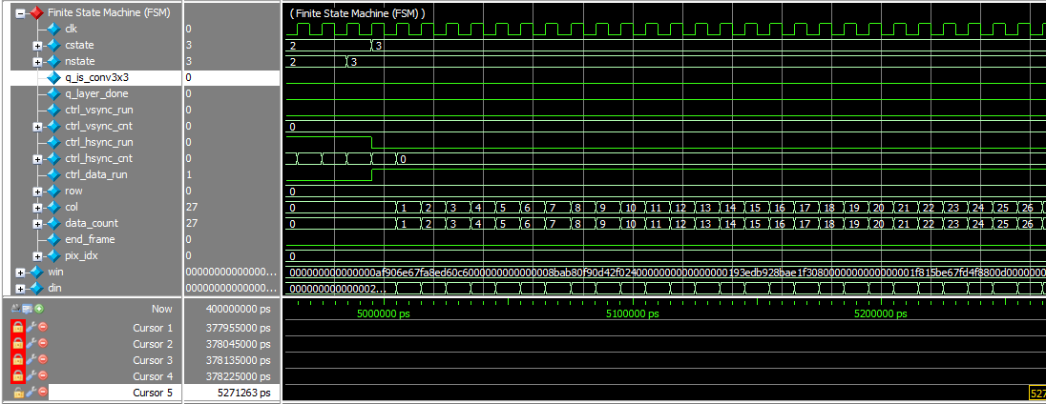

Fig. 3-1: A captured waveform of FSM for conv1x1.

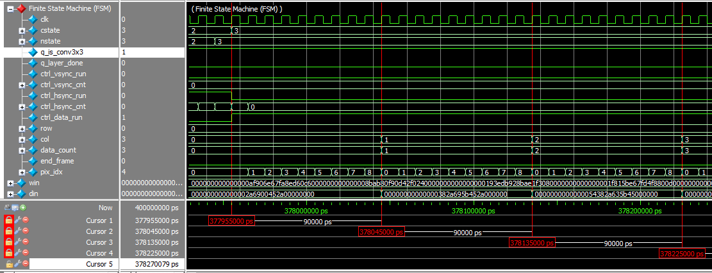

Fig. 3-2: A captured waveform of FSM for conv3x3.

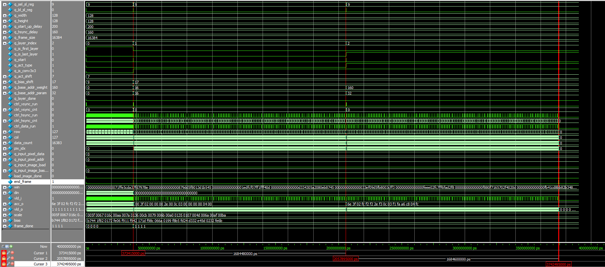

Fig. 3-3: Simulation results.

**Solution 3: Convolution 3x3**

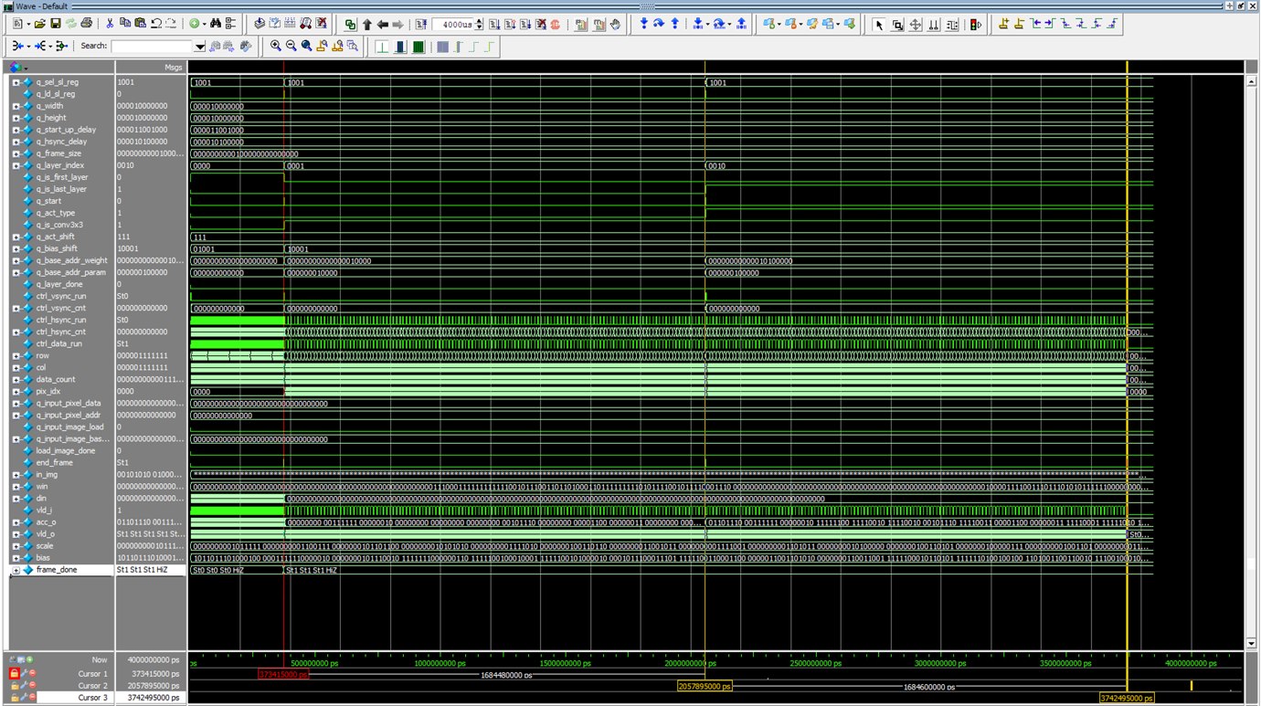

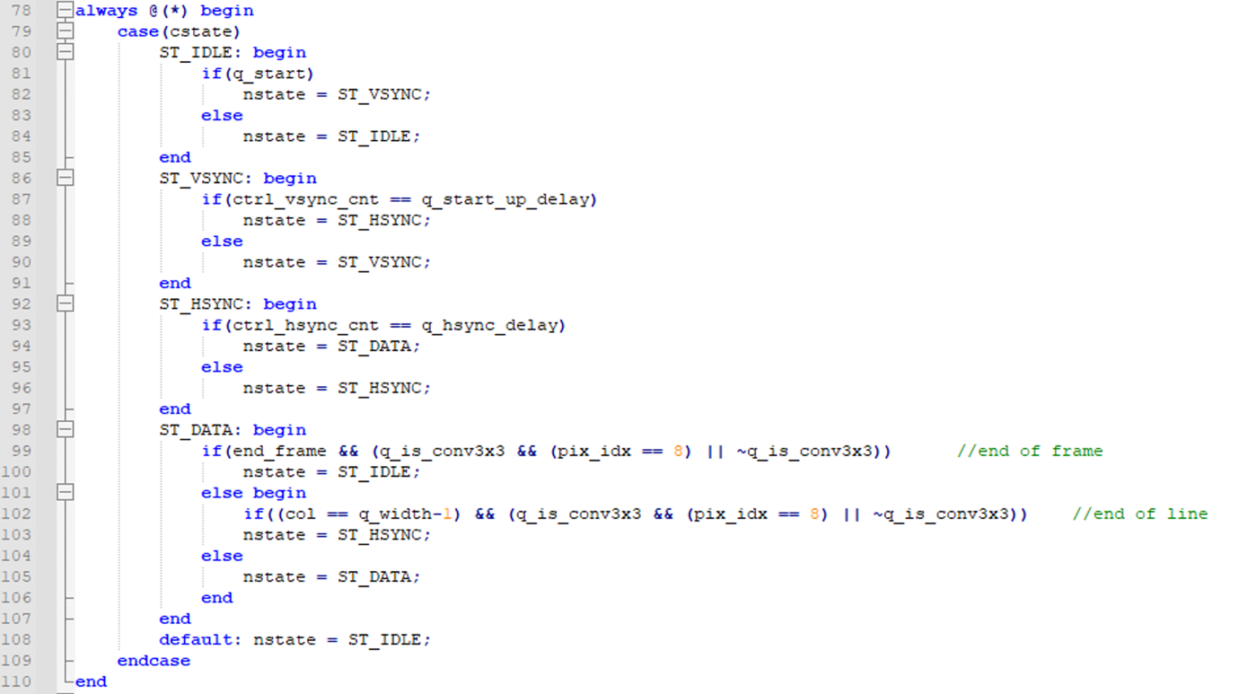

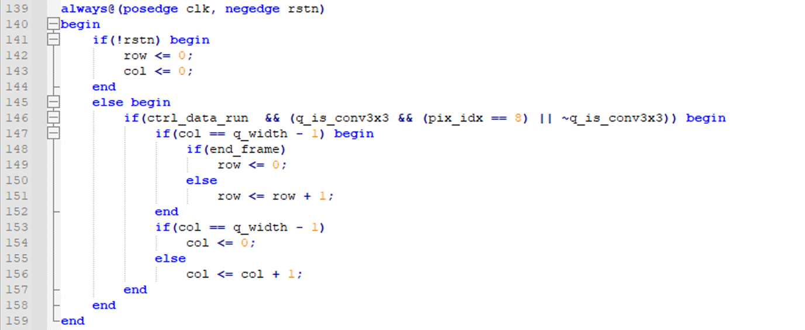

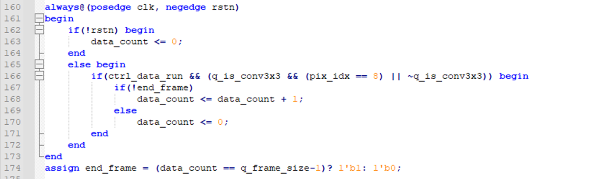

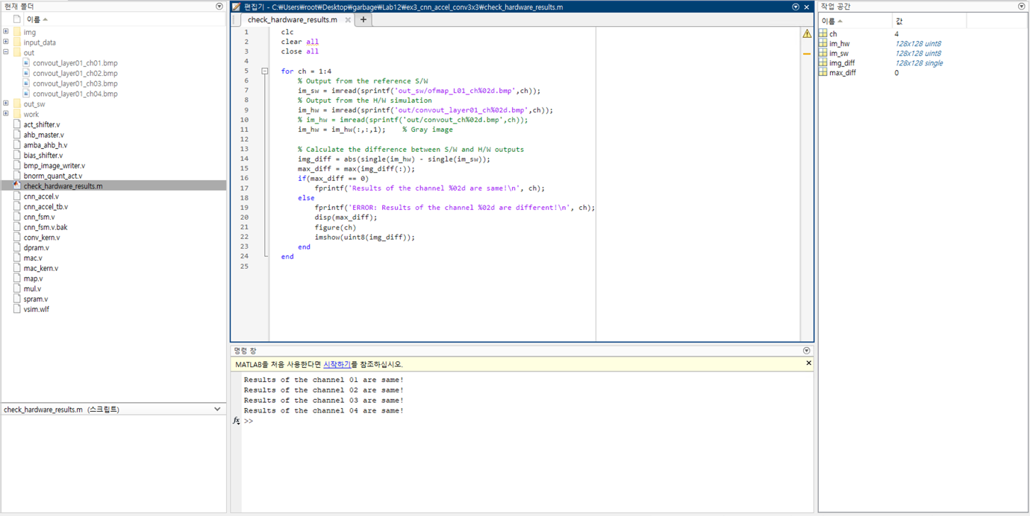

**Problem 4: (Optional) (2p)**

As shown in Fig.4-1, the readout ports (Port B) of dual feature map buffers are open. Generate the enable signal (enb) and the address (addrb) signals of port B for both dual buffers.

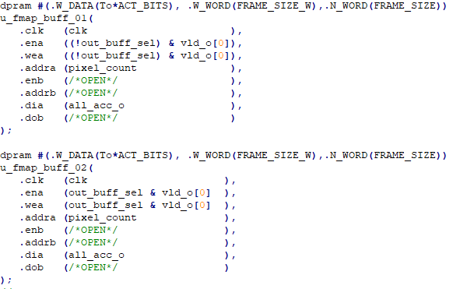

Fig. 4-1: Dual output buffers

**Solution 4: Optional**

